**SSH into Ansible node from Terraform server**

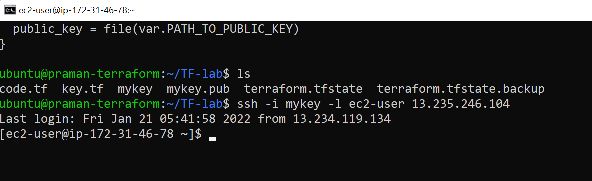

**Ansible Webserver**



